How far was the SIMF response group as of November 30, 2012

?

Version 2012-12-01-1925-SN

Sjir believes it is useful for SIMF to start a document describing the points of agreement. *Every one in the response group is invited to correct and extend this text.*

**Agreement 1: Only one type-instance construct**

The SIMF CDM language wil have only one type-instance construct.

Cory, Paul and Sjir had this principle as a proposal in their papers submitted to the SIMF response group.

It has been discussed many times during the telecons.

The agreement has been voted on and the vote has been confirmed at least once (listen to audio records of Cory).

There is agreement on the construct, but so far no agreement on the name for the construct.

Sjir prefers to call this type-instance construct at M0 level a ground fact.

Cory prefers to call it assertion.

Cory and Sjir have indicated they are willing to accept the term of the other.

Hence this is a solvable problem that can be voted on when needed.

**What is the instance of a type-instance construct?**

A type-instance construct at the M0 level, the instance ground level can best be introduced by a representative set of examples, is the conviction of Sjir, and then followed by a definition.

Examples of ground facts from the context of Famous Composers

1. Mozart visited Italy in 1769.
2. Mozart visited France in 1763.
3. Verdi visited France in 1853.
4. Mozart was born in Austria.
5. Mozart died at the age of 35.
6. Verdi was born in Italy.
7. Verdi died at the age of 87.
8. The capital of Austria is Vienna.
9. The capital of Italy is Rome.
10. Bach was born in Germany.

For the time being Sjir prefers to call each of these 10 examples a ground fact; Sjir is willing to accept another name than ground fact.

In the telecom 0f Nov 26, 2012, there was a preference to include the term data, qualified in one way or another.

How would data-fact do for the time being? Or fact-data?

**The structure of a ground fact**

The structure of a ground fact consists of a verb part with an associated ordered set of ground objects.

There are no quantifiers (some, all) in a ground fact, nor an OR, implies of equivalence operator.

There are many communities that consider an AND natural (Mozart was born in Austria *and* died at the age of 35.) Sjir remembers Roger to have asked for this.

Even the NOT is by several communities appreciated at the ground (M0) level.

Examples to illustrate the structural aspect, with corresponding colors:

Mozart visited Italy in 1769.

Mozart was born in Austria.

Bach was born in Germany.

Some more examples of ground facts from the context of the Nobel Prize and possible future winners and a few facts about them

Examples: (legend: predicates in non-italics, (individual) constants in italics)

*Serge* was born in *Algeria*.

*Harald* was born in *Germany*.

*Serge* visited *Greece* in *2005*.

*Harald* visited *The Netherlands* in *2010*.

*The Nobel Peace Prize* is awarded in *Oslo.*   
 (Binary fact) [Elementary and asserted]

*The Nobel Prize in Physics* is awarded in *Stockholm*.   
 [Elementary and asserted]

*The Nobel Prize in Physics* is *28* times shared by *three* Laureates.  
 (Ternary fact) [Elementary and derived]

*The Nobel Prize in Chemistry* is *22* times shared by *two* Laureates.  
 [Elementary and derived]

*The Nobel prize in Chemistry* of *1954* was awarded to *Linus Pauling*.  
 (Ternary fact) [Elementary and derived]

*The Nobel Peace Prize* of *1962* was awarded to *Linus Pauling*.  
 [Elementary and derived]

The Nobel Laureate *Elizabeth H. Blackburn* of *the* *Nobel Prize in Physiology or Medicine* in *2009* was awarded for the work *"of how chromosomes are protected by telomeres and the enzyme telomerase"*.  
 (Quaternary fact) [Compound and derived]

The Nobel Laureate *Willard S. Boyle* of *the Nobel Prize in Physics* in *2009* was awarded for the work *"for the invention of an imaging semiconductor circuit - the CCD sensor"*.  
 [Compound and derived]

*George E. Smith* was awarded for his work *“for the invention of an imaging circuit – the CCD sensor”*.  
 (Binary fact) [Elementary and asserted]

The award received by *George E. Smith* for his work *“for the invention of an imaging circuit – the CCD sensor”* resulted in *¼* of the prize.  
 (Ternary fact) [Elementary and derived]

The work *“for the invention of an imaging circuit – the CCD sensor”* was awarded *the Nobel Prize in Physics* *2009*.   
 (Ternary fact) [Compound and asserted]

Compound, because there are 2 elementary facts:

1. The work *“for the invention of an imaging circuit – the CCD  
 sensor”* was awarded *the Nobel Prize in Physics*

2. The work *“for the invention of an imaging circuit – the CCD  
 sensor”* was awarded in *2009*

Within the collection of all Nobel Prizes *the Nobel Peace Prize* identifies a specific Nobel Prize.  
 (Unary fact). [Existential and asserted]

Within the collection of all Nobel Prizes *the Nobel Prize for Physics* identifies a specific Nobel Prize.   
 [Existential and asserted]

-----------------------------------------------------------------------------------------------

Please note that a (ground) fact does not contain any rule aspect. Often it is referred to as a declarative fact; maybe SIMF will use data-fact, or fact-data.

An example of a rule is:   
 <The Nobel Price> is awarded in **exactly one** <City>

Please note that in a rule there are variables, represented between <…>; a ground fact or assertion does not contain any variable. A ground fact contains one or more instantiations of a variable.

**What is the type of a type-instance construct?**

The type of a type-instance construct specifies which *kind* of ground facts are considered within scope of a certain CDM, or context.

The structure of a fact type is a predicate plus an ordered set of variables.

Examples:

<Famous composer> was born in <Country>.

<Famous composer> visited <Country> in <Year>.

Each variable is between a pair < >. The remainder of the fact type is the predicate.

**What is the population of a type-instance construct?**

A population of a type-instance construct at time t is the set of all ground facts available that satisfy the type specification, and satisfy the integrity rules (definition follows).

**Agreement 2: CDM makes the distinction between elements in the domain and the refences to the elements in the domain**

To illustrate the distinction between the elements in the domain and the references to the elements in the domain, Sjir has developed an example of a deep ground fact presented and illustrated step by step hereafter.

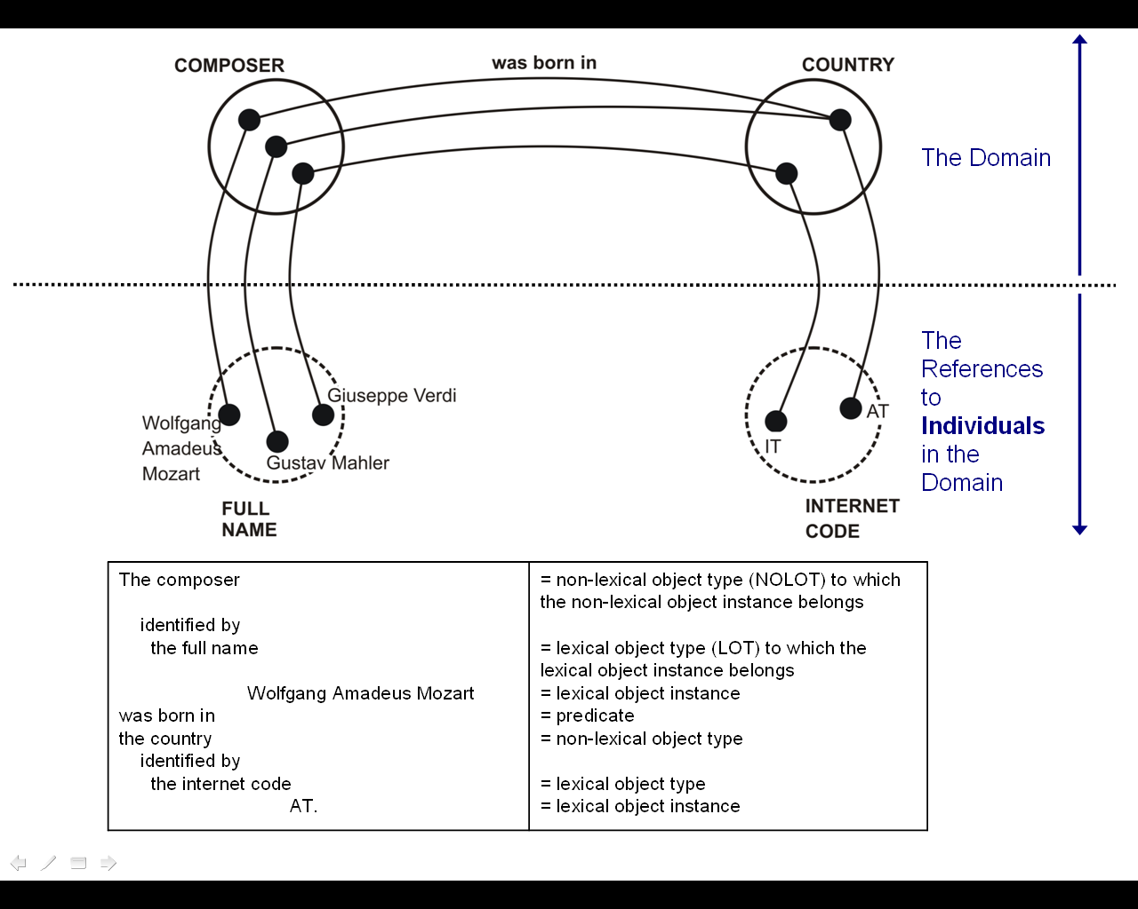

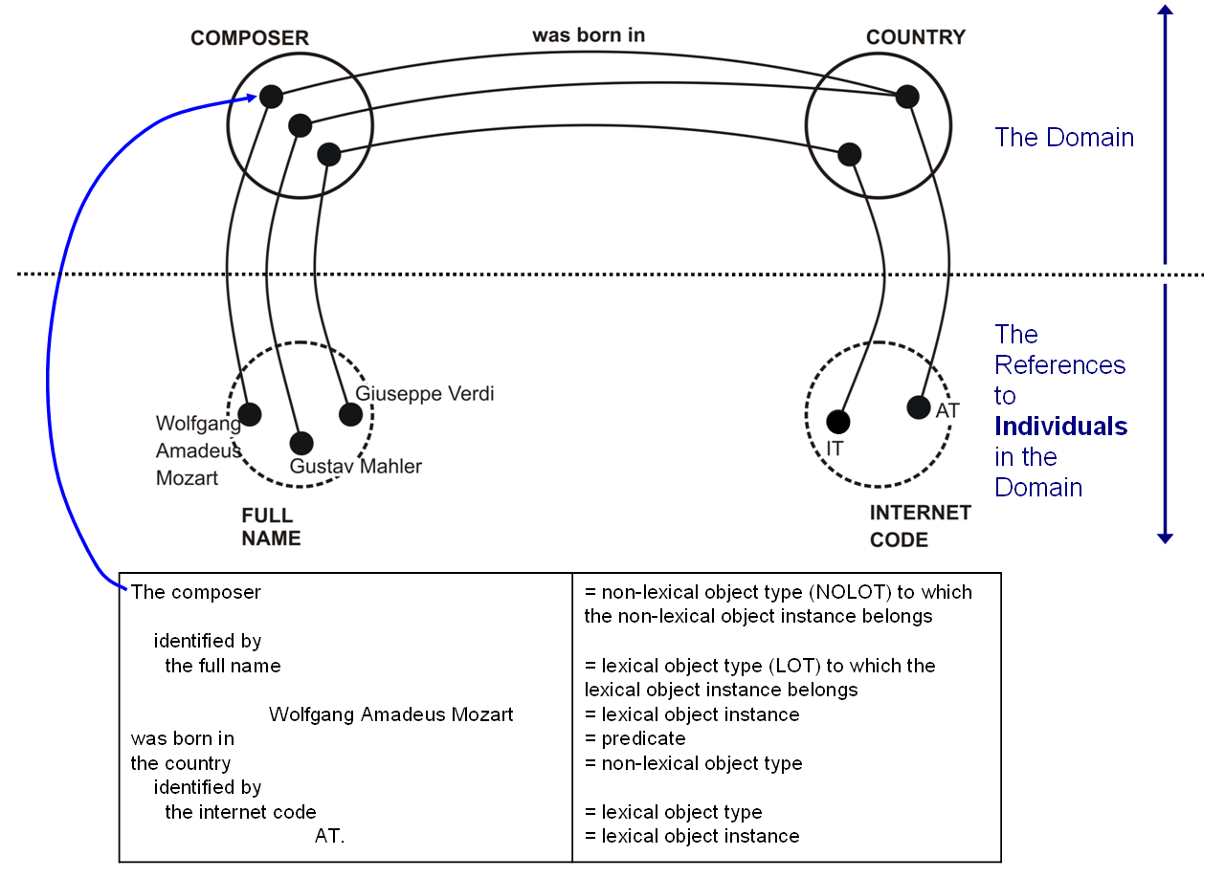

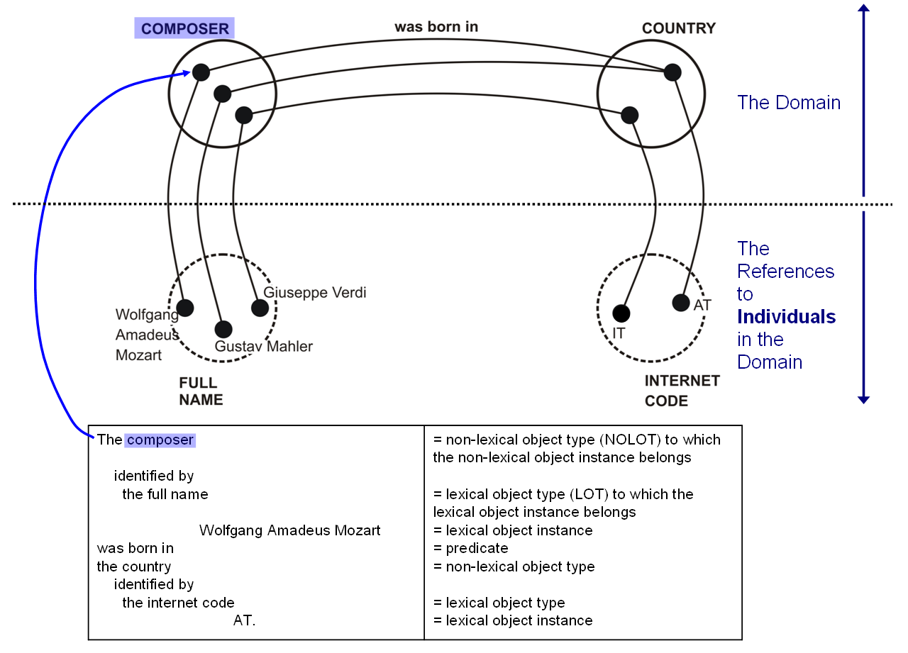

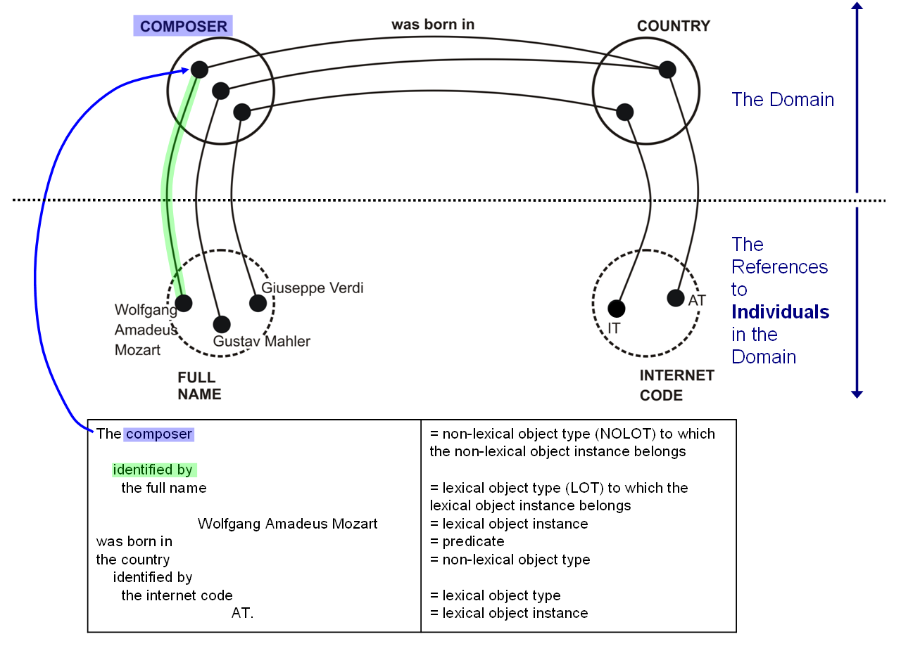

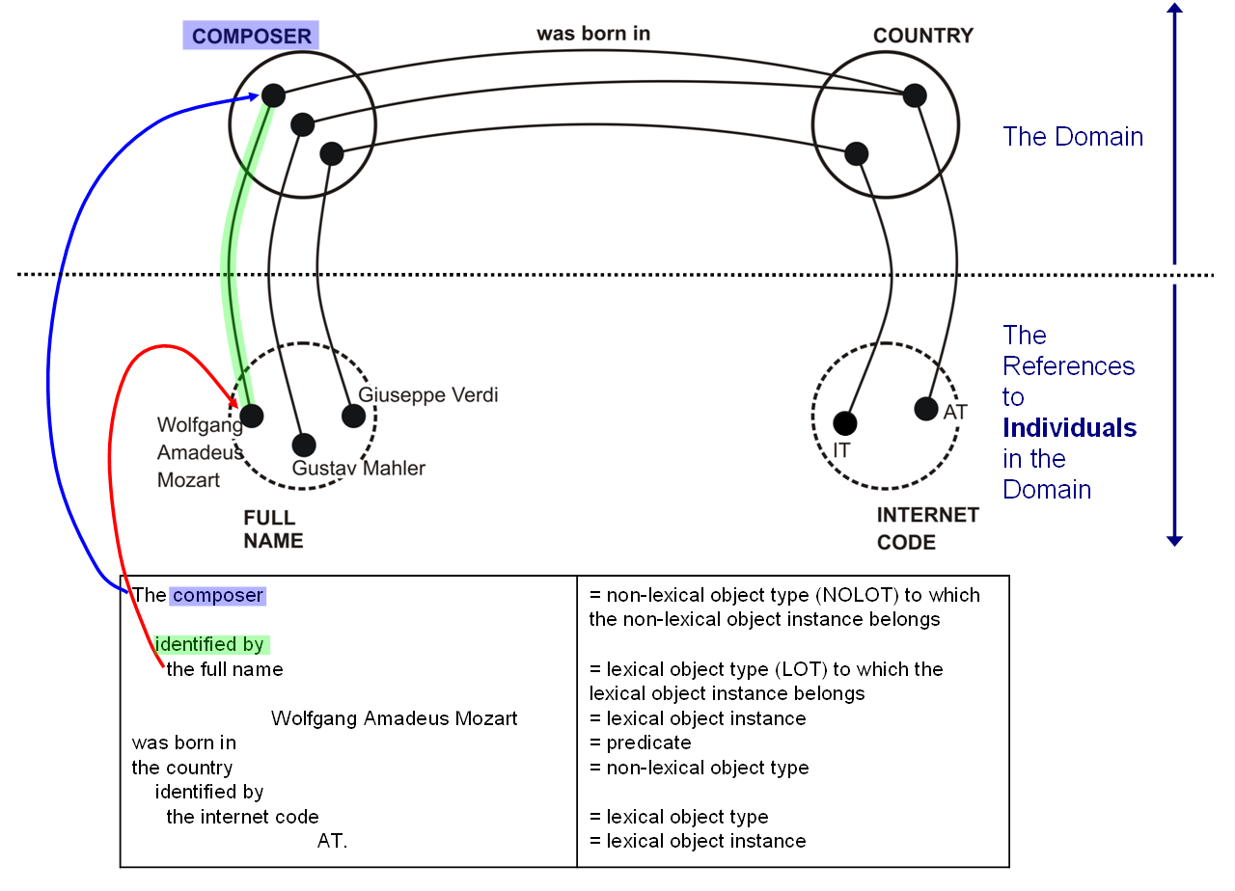

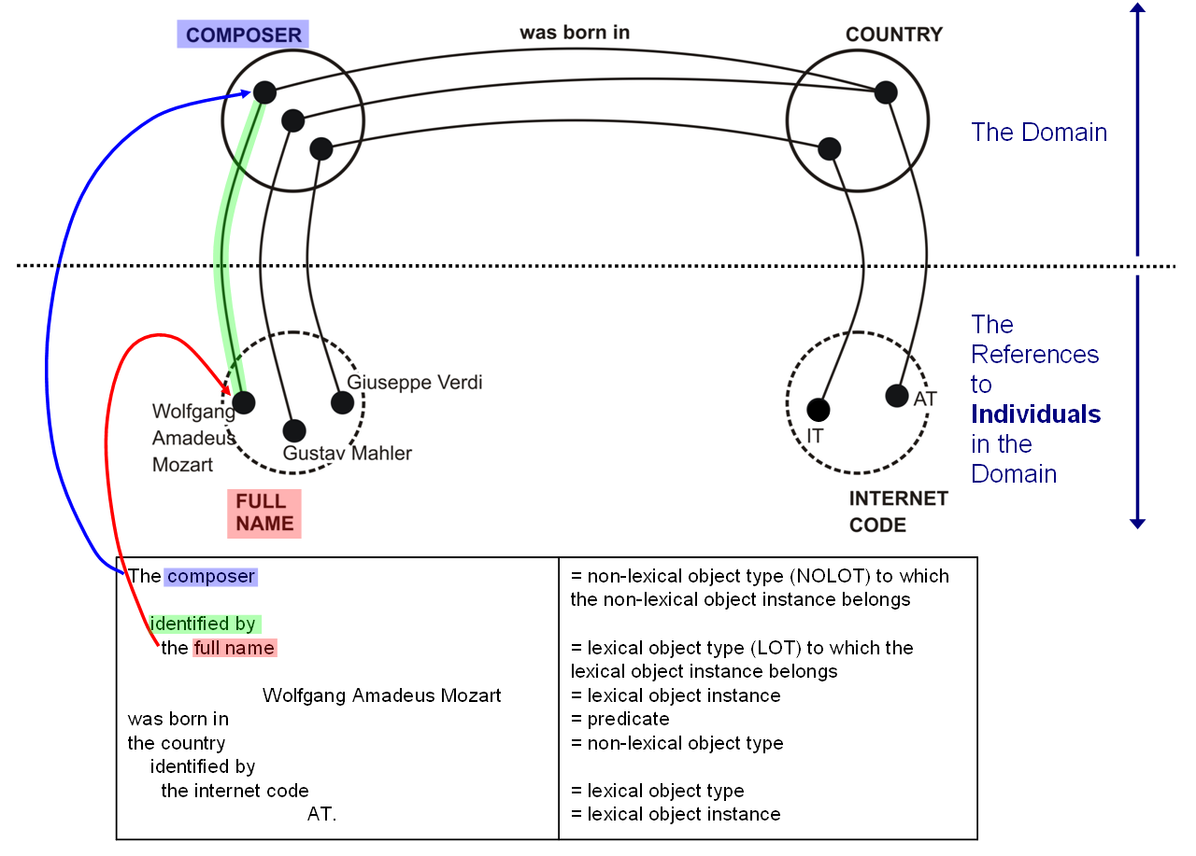

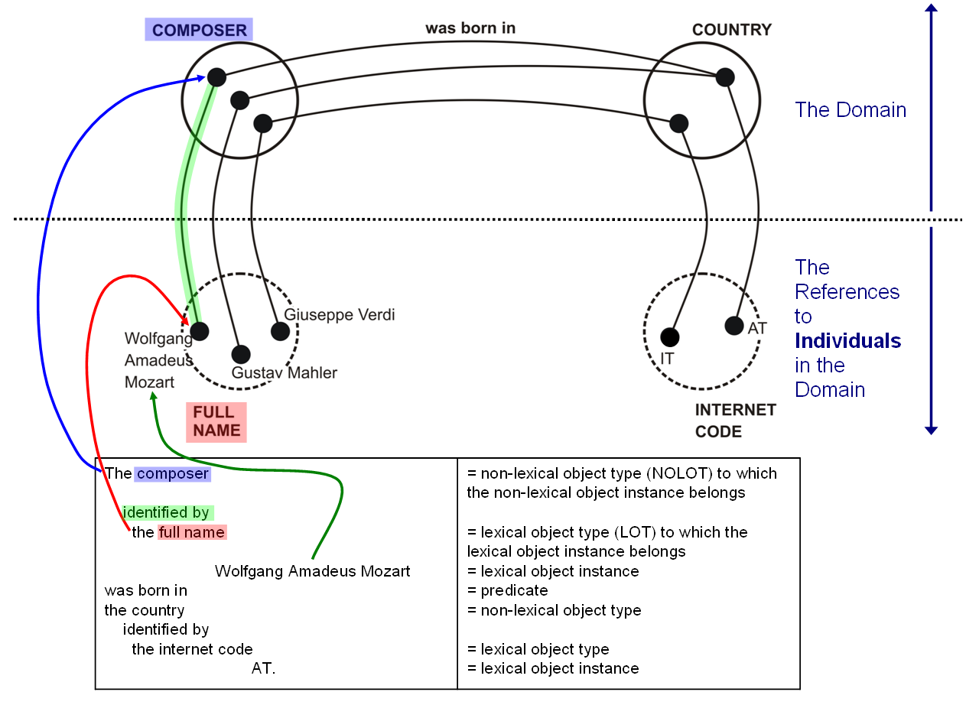

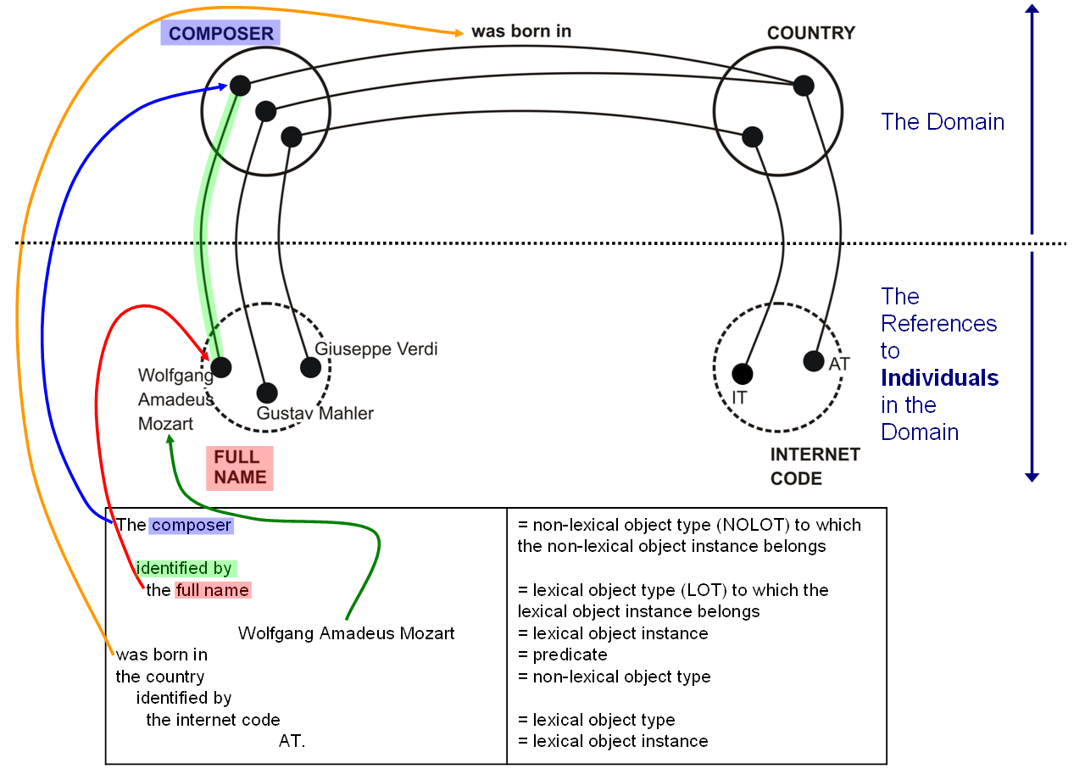

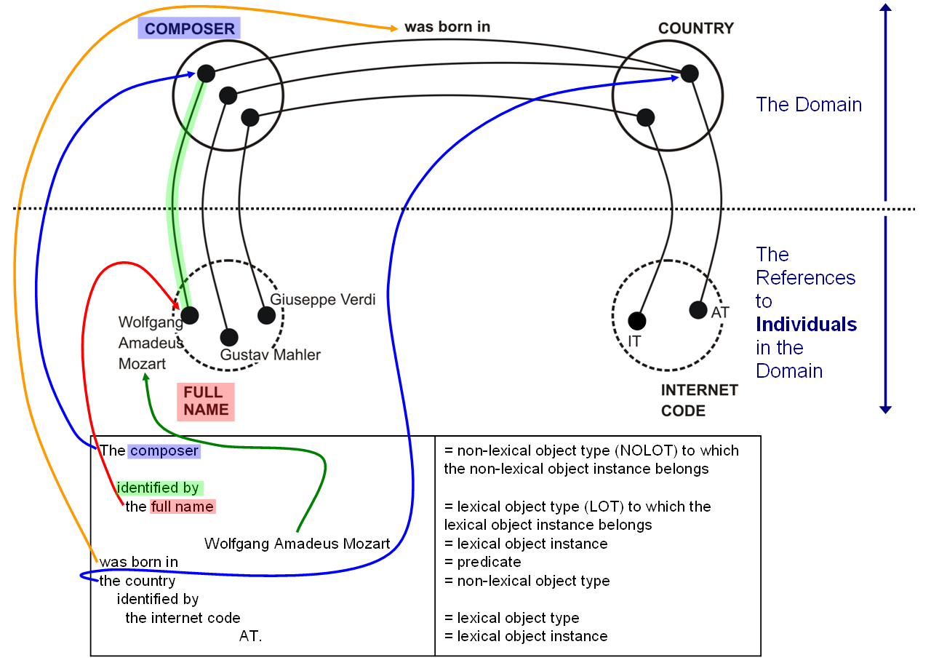

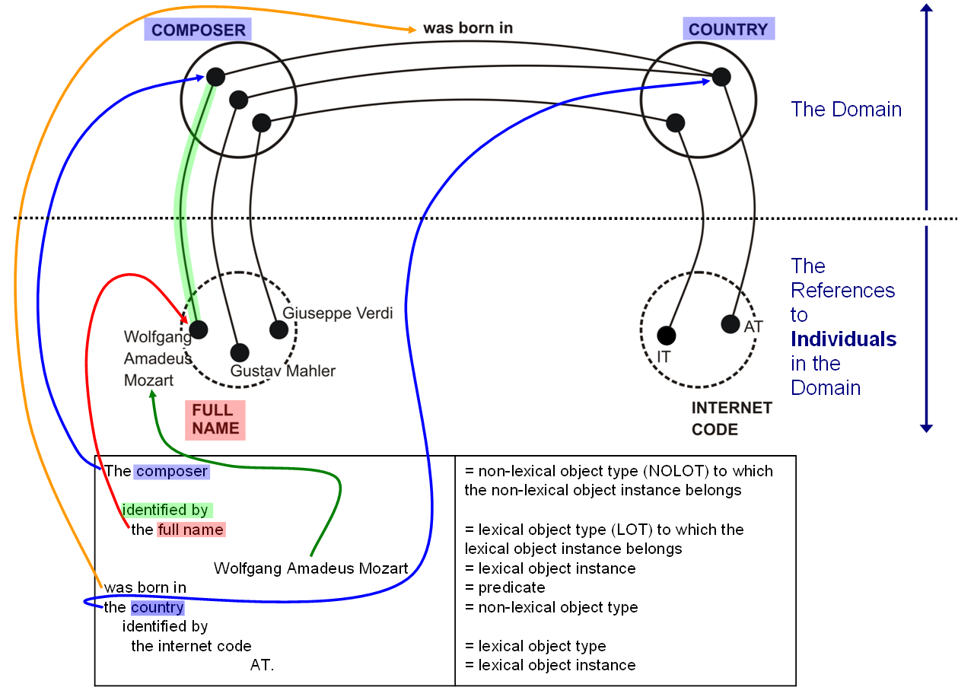

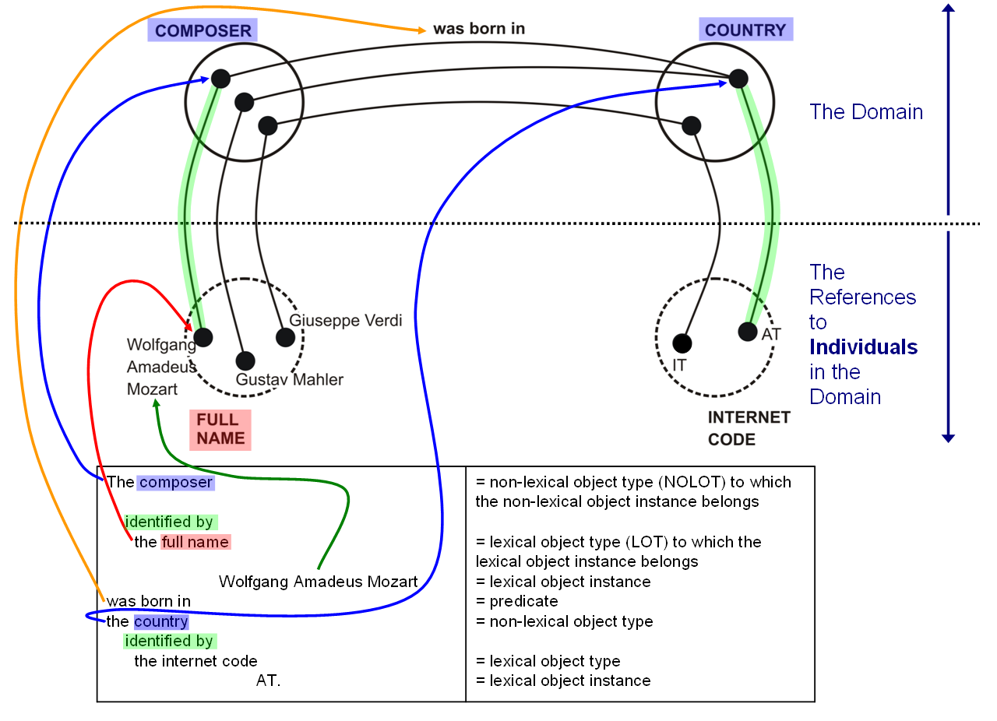

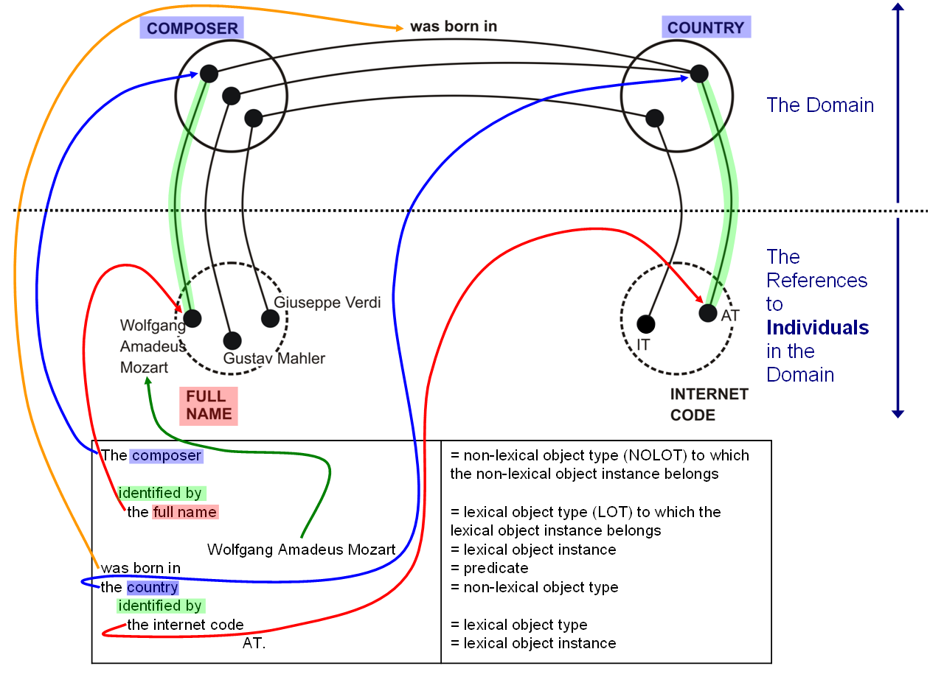

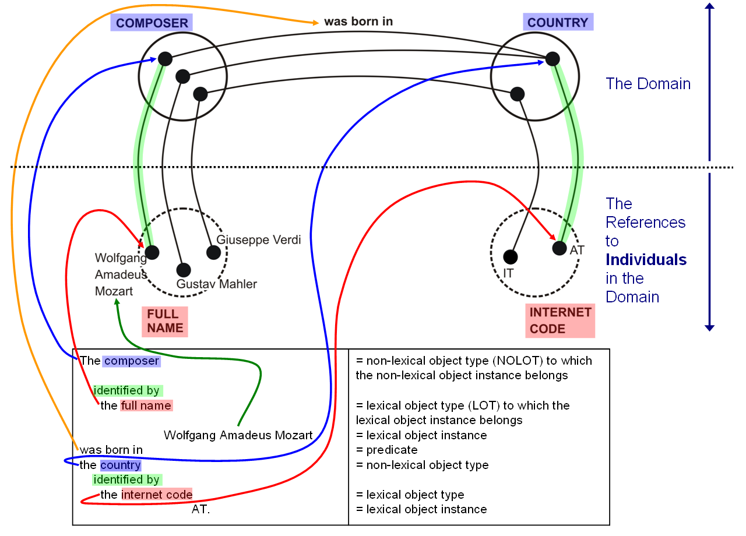

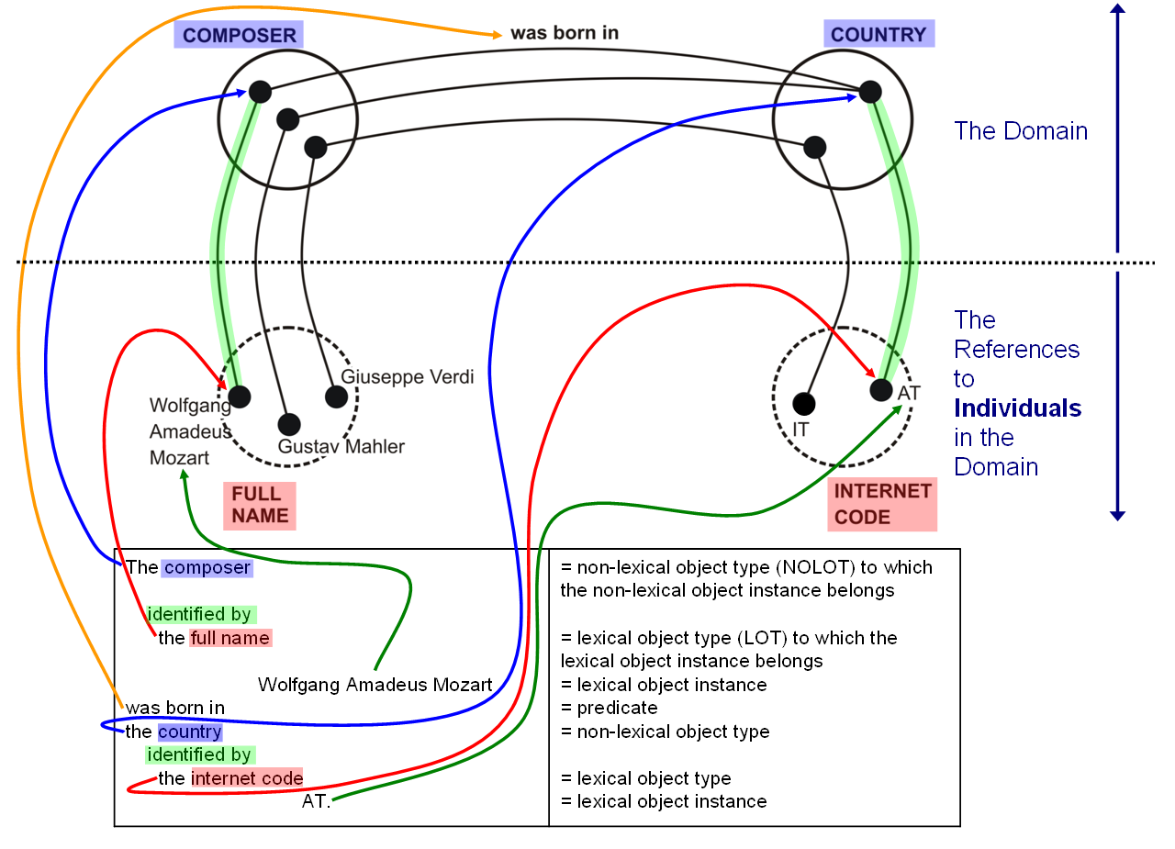

**Conceptual Domain Model**

The Conceptual Domain Model consists minimally of

1. A set of fact types,
2. A set of associated integrity constraints and
3. A set of concept definitions.

Definitions of elements of the CDM

**Fact type**

For every system, subject or domain, there is a need to identify and fully define those kinds of ground facts that are considered to be part of the system, subject or domain, i.e. define the scope precisely.

Notes:

* 1. The fact type is the populatable construct.
  2. This knowledge level II type (M1 in OMG) of construct is the only one that has corresponding instances at level I (M0 in OMG).
  3. By definition, all other facts are considered “out of scope”.

**Rules**

**Integrity rule aka integrity constraint or validation rule**

The set of facts at level I, and transitions between sets of facts, need to be restricted to those that are within scope, or permitted.

It is the function of the integrity or validation rules to restrict the populations made possible by the fact types and their transitions to permitted ones.

Notes:

1. Fact types determine that fact instances of the corresponding fact type (i.e. having the same [deep structure] verb) are permitted at all.
2. Integrity rules further restrict the fact populations and transitions made possible by the fact types.

**Derivation rule**

Facts are asserted by the outside world, often called the environment of the system or context and are thereafter considered part of the set of the ground facts.

In addition to those facts that are asserted, in practice, there is a need to derive facts from other facts in the population, asserted or derived.

This is done through the use of derivation rules.

**Exchange rules**

Exchange rules describe the processes how facts from the environment will be accepted as asserted facts, or that the environment requests to remove certain asserted facts from the set of ground facts.

The function of an exchange rule is to move facts from the outside world into the system, or the layer of facts, or remove facts from the layer of ground facts.

This knowledge category gives an answer to the following question: How are the contents of the fact population inside the system or context altered, or kept in sync with the wishes of the environment?

**Behavioural rule**

A behavioural rule is a rule that an actor needs to follow. In case the actor does not follow the rule and this fact is observed, there is a derivation rule or exchange rule that specifies what the sanction is or should be.

**Concept definition**

The function of the CD knowledge category is to define every term or group of terms :

1. that are used in expressing ***ground facts*** orelements of the ***domain specific conceptual schema,***
2. for which the assumption is made that their meaning may not be fully clear to the *speech community*.

Notes:

The speech community is also known as intended audience

**Communication pattern**

In order to provide the functionality that the fact instances (M0) as well as the rules (M1) can be communicated in a speech community specific jargon, the concept “communication pattern” is used, with two specializations.

A fact communication patterns may either represent :

1. a fact pattern, e.g.:

<President> married <Spouse>

1. or an object pattern, e.g.:

The marriage of <President> and <Spouse>

Notes:

1. Every fact type has one or more communication patterns associated to given speech communities.

A rule communication patterns is used to specify a rule associated with the fact type.

Example:

Each Famous composer was born in exactly one Country.

or expressed as follows:

Each <Famous composer> was born in exactly one <Country>.

**Process**

A process is a fact consumer or a fact generator. A process is executed by an actor.

**Actor**

An actor is an executor of a process or the party that has the freedom to violate or follow a behavioural rule.

**Event**

To make a system useful in practice it is needed to have a functionality to define when to start a derivation rule or an exchange rule.

**Agreement 3: A complete CDM includes integrity constraints**

This agreement was reached during the telecon of 2012-11-19.